

SUPERIOR UNIVERSITY LAHORE
GOLD CAMPUS

NAME: MUHAMMAD MOIZ RAZA
ROLL NO: SU92-BSAIM-F24-061
PROGRAM: ARTIFICIAL INTELLIGENCE
SEMESTER: 4th SEMESTER
SECTION: BSAI-4A
SUBJECT: PROGRAMMING OF AI (LAB)

Submission Title: LAB TASK 5
Submitted To: Sir Rasikh Ali

TITLE: Image processing, Segmentation, and feature analysis using opencv and python

Step 1: image processing and enhancement
overview
in this step, basic image processing techniques are applied to prepare and improve images. operations like resizing, blurring, grayscaling, and normalization are used to make images easier to analyze and visualize.
working
- read and resize the image using cv2
- apply gaussian blur, median blur, and bilateral filtering to reduce noise
- convert images to grayscale using weighted and average methods
- normalize pixel values and detect edges using the canny edge detector
features
- image resizing and scaling
- multiple blurring and filtering methods
- grayscale conversion
- edge detection
uses
- reduce noise and enhance images for analysis
- highlight important features like edges and intensity variations
- prepare images for further processing

Step 2: image segmentation and thresholding
overview
thresholding techniques are used to separate objects from the background and divide images into meaningful regions. adaptive and otsu thresholding methods handle varying lighting and automatic threshold selection.
working
- convert image to grayscale
- apply binary, inverted, truncated, and zero thresholding
- use adaptive mean and gaussian thresholding
- apply otsu’s method for automatic threshold selection
features
- simple and adaptive binary segmentation
- automatic threshold selection with otsu
- handles varying lighting conditions
uses
- detect and isolate objects
- prepare images for morphological operations and feature extraction

Step 3: morphological operations and filtering
overview
this step improves the shape and clarity of objects in an image using operations like erosion, dilation, opening, and closing. noise is reduced while keeping edges intact.
working
- apply erosion and dilation on grayscale images
- perform opening and closing to refine object shapes
- apply bilateral filter to smooth colored images while preserving edges
- denoise images using fastNlMeansDenoisingColored
features
- shape enhancement of objects
- noise removal
- edge preservation
uses
- improve object boundaries for better analysis
- reduce noise to support accurate feature detection

Step 4: advanced image manipulation and background subtraction
overview
advanced techniques are applied to repair images, separate foreground from background, and model background dynamically in video.
working
- restore damaged areas using image inpainting
- update background model from video using running average
- extract foreground objects using the grabcut algorithm
features
- object extraction
- background modeling
- image restoration
uses
- surveillance and tracking
- repair damaged images
- isolate objects from complex backgrounds

Step 5: feature detection and description
overview
this step focuses on identifying important structures like lines, circles, corners, and blobs. keypoints are extracted using sift and orb for feature matching.
working
- detect edges using canny
- detect lines using hough transform
- detect circles using houghcircles
- detect corners using goodfeaturestotrack, shi-tomasi, and harris
- detect blobs using simpleblobdetector
- extract keypoints and descriptors using sift and orb
features
- line, circle, and corner detection
- keypoint extraction for feature matching
- blob detection for analyzing shapes
uses
- object recognition
- feature matching and tracking
- image analysis and classification

Step 6: feature detection and analysis
overview
this step analyzes images using contours and histograms, allowing insight into object shapes, sizes, and intensity distributions.
working
- find contours and annotate coordinates
- calculate grayscale and color histograms
- visualize pixel intensity distribution using cv2 and matplotlib
features
- contour detection and annotation
- grayscale and rgb histograms
- pixel intensity visualization
uses
- analyze object shapes and locations
- assess image quality
- understand patterns and intensity distributions
Conclusion
In this lab task, we explored various image processing and computer vision techniques, from basic enhancement and filtering to advanced feature detection and analysis. These methods help in preparing images, extracting meaningful features, and understanding image content, forming a strong foundation for real-world applications like object recognition, image restoration, and automated analysis.

Screenshot:
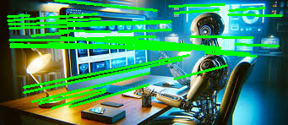
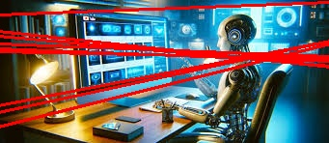
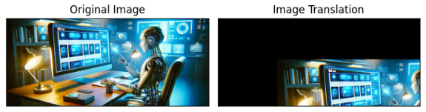

THE END

